IJES Cover Letter and

Submission Checklist

IJES requires the following in a combined file: 1) a cover letter (see example below) and 2) a checklist to be included in the submission. Please download this document and complete all required items (click “File” > “Download” > “Microsoft Word”). Upload this single document in the “Cover Letter” location of the submission (this option follows “Full Text of Submission”, do not paste into the dialogue box).

# General

* You are aware and accept the indexing $499 USD fee that will be charged ONLY IF your paper is accepted.
* The editors certainly understand that manuscripts will possess some level of similarity between other published works. We evaluate each submission to ensure that there is a minimal level of agreement, and most often we find short phrases, common terms, and the like to be identified. If submissions contain  long runs of sentences and paragraphs that match previously published or available work (even if the language repeated is yours), IJES cannot consider the duplication as it may be viewed as an infringement of copyright.
* Put together a list of potential student and professional reviewers who may be able to evaluate the manuscript. Be ready to provide names and email addresses during the submission upload process.
* Place a 12 pt space between each paragraph.

# Cover Letter: A Separate Document From Manuscript

A scientific cover letter for a manuscript submission provides a brief summary of the study's significance, highlights its key findings, and explains its relevance to the journal's scope. It introduces the manuscript to the editor, emphasizing why it is a strong fit for publication. This should be no more than two paragraphs.

Due to the double-blind nature of the peer-review process, authors must also include identifiable information related to themselves within the cover letter (do not include identifiable information in the manuscript). It is a policy of IJES that Student Investigators are included in the authors list by contributing significantly to the development of the submission. Below is how to format your author list in the cover letter.

## Identifying authors:

Academic status designation first (Student Investigator*, Early-Career Investigator†, or Established Investigator‡), then school or department and university affiliation (if needed when two or more schools are represented, use 1,2). If two authors contribute equally to the paper, consider also including a # symbol after school designation.

* All papers must include at least one Student Investigator or Early-Career Investigator. Failing to meet this expectation will result in desk rejection without further consideration.

# Cover Letter Example

*Please replace the black text specific to your submission. Delete the red text.*

Date

Editor-in-Chief,

I am pleased to submit my manuscript, titled *"[Title of Your Study]"*, for consideration in the *International Journal of Exercise Science*. This study investigates the potential impact of cannabidiol (CBD) on recovery following exhaustive exercise, contributing to the growing interest in nontraditional recovery aids in sports science.

With the increasing prevalence of CBD use among athletes and active individuals, our research aimed to assess its effects on key markers of recovery, such as [list primary metrics, e.g., inflammation, muscle soreness, or performance recovery metrics]. Using a [describe methodology briefly, e.g., double-blind, placebo-controlled] approach, we observed that CBD [highlight a key finding, e.g., reduced muscle soreness and improved subjective recovery scores]. These findings align with emerging literature while providing novel insights into the application of CBD for exercise recovery.

The manuscript is an original work and has not been submitted or published elsewhere. We declare no conflicts of interest to disclose (alternatively, disclose potential conflicts of interest here in the cover letter). All authors have approved the final version.

Sincerely,  
[Your Name]  
[Your Title/Position]  
[Your Institution]

**Author Information**

Whitley J Stone‡1, Grant T Malone†1,2, Dustin W Davis‡3, James W Navalta‡3

1. School of Kinesiology, Recreation, and Sport, Western Kentucky University, Bowling Green, KY, USA
2. Department of Kinesiology, University of Alabama, Tuscaloosa, AL, USA
3. University of Nevada, Las Vegas, Las Vegas, NV, USA

Optional: Include [ORCID](https://orcid.org/) (if you would like to link your publication)

Corresponding author:

Whitley Stone

[whitley.stone@wku.edu](mailto:whitley.stone@wku.edu)

# IJES Submission Checklist

IJES requires this checklist to be included in the submission of your cover letter. When completing the checklist, please include the line numbers within the manuscript where each item can be found (for applicable items). Please read each notation on the checklist and mark that it has been understood and, where applicable, addressed by the authors.

Note checklists specific to Original Research, Systematic Reviews and Meta-Analyses, and Qualitative Research. You may delete the other types of checklists.

# Manuscript Submitted for Peer Review

## Front Matter

* There should be no identifiable information related to authors within the manuscript document submitted for review.
* Include a < 250 word abstract drafted according to the guidelines on the [prepare your manuscript](https://digitalcommons.wku.edu/ijes/styleguide.html) page. Do not include section categories (i.e. Introduction, Methods, Results, Discussion). No citations are permitted in this section.
* Include 3–5 keywords not found in the title.

## In-Text Citations

All in-text citations should be according to the [AMA Style](https://owl.purdue.edu/owl/research_and_citation/ama_style/index.html). References should be cited in the text using superscript Arabic numerals. Superscript numbers should be **outside periods and commas** but **inside colons and semicolons**. Cite multiple references in the same instance. If citing sequential references, they should be indicated with a hyphen. Non-sequential references should be separated with commas. There should be no space between numbers. The AMA recommends not placing a superscript reference citation immediately following a number, and advises revising the sentence to prevent confusion with an exponent. Note that, unlike other citation styles, a period does not follow “et al.” unless found at the end of a sentence.

Examples

1. Citing at the end of a sentence:
   * High-intensity interval training has been shown to improve VO2 max significantly in trained individuals.1
2. Citing in the middle of a sentence:
   * Resistance training, as demonstrated by Smith et al,2 enhances muscular strength and endurance across multiple populations.
3. Citing multiple non-sequential references:
   * Dynamic stretching improves performance metrics in athletes, while static stretching may impair them.3,14
4. Citing a range of sequential references:
   * Numerous studies1-3 have reported significant improvements in cardiovascular health with consistent aerobic exercise.
5. Citing within parentheses:
   * The findings align with prior research (e.g., Hill et al5), which reported similar increases in metabolic rate post-exercise.

# Original Research Articles

## Introduction

The introduction in a scientific article sets the stage for the study by providing background information, identifying gaps in the literature, and establishing the study's significance. It outlines the research problem, offers context by summarizing relevant previous work, and concludes with the study's objectives and hypotheses. A strong introduction engages the reader, justifies the study's importance, and clearly connects the research question to broader scientific or practical applications.

## Methods

Methods sections in scientific articles provide a detailed and transparent account of the procedures used to conduct a study They allow other researchers to replicate or reproduce the study, validate findings, and build upon the research. A well-written methods section includes descriptions of the study design, participant demographics and recruitment, justification of the sample size, materials and equipment, data collection procedures, and statistical analyses. Clear and concise methods statements enhance the credibility of the study and ensure the validity of its conclusions.

### Ethics

If the submitted study involved human participants, authors must include a statement of informed consent (or assent when necessary) and human subjects approval from your institutional review board obtained before starting the study. This also requires that participants provide consent before data collection. Beyond these ethical requirements, IJES also requires the following,

(1) include a statement similar to, "This research was carried out fully in accordance with the ethical standards of the *International Journal of Exercise Science,*" acknowledging alignment with the ethical policies of IJES and

(2) include a [citation to](https://digitalcommons.wku.edu/ijes/vol12/iss1/1/) Navalta JW, Stone WJ, Lyons TS. Ethical issues relating to scientific discovery in exercise science. *Int J Exerc Sci.* 2019;12(1):1-8.

* **Type the line number where this is found ______**

### Sample Size

For quantitative study designs, the editors will look for either an (1) *a priori* power analysis or (2) a scientific rationale for the number of participants tested that is accompanied by a rationale for why a power analysis could not be conducted. If you have any questions regarding this requirement, please reference the editorial published in [volume 13(1) 1-5](https://digitalcommons.wku.edu/ijes/vol13/iss1/1/).

Examples of sample size justification:

Example 1: Sample size was generated using a sample size calculator for reliability studies.1 Based on data from Gant et al,3 a minimum acceptable intraclass correlation coefficient (ICC) of 0.6, an expected ICC of 0.9, a power of 80%, and two replicates per participants (*k* = 2) yielded a required sample size of 14. Of the 20 volunteers, two individuals were excluded for inability to demonstrate safe exercise technique, while one individual was excluded after sustaining an injury outside of this investigation. Therefore, final analysis was completed on seventeen individuals (*n* = 5 females/12 males/0 specified otherwise).

Example 2: *A priori* power analyses were conducted with G*POWER 3.1.9.2 (Universitat Kiel, Germany) software. A meta-analysis across 32 primary studies reported an average effect size of 0.81 (95% CI 0.44–1.19I) for athletes to have a PAPE of subsequent muscle power activities at 7–10 minutes following a CA.49 Thus, for a statistical power of 1−β = 0.80, α = 0.05, and with an effect size of 0.81 as meaningful can be achieved with nine participants across two groups. The sample size in the current investigation was *n* = 9 participants across two within-subjects’ groups.

The participant number should be accompanied by a citation that justifies the numbers included in the evaluation.

* **Type the line number where this is found ______**

Include an interpretation of effect size or secondary measure in the statistical analysis section that accompanies the reported results.

* **Type the line number where this is found ______**

For qualitative study designs, the editors will look for a theoretical or empirical justification of the sample size based on the population sampled and methods used.

### Protocol

It is essential to provide a step-by-step account of the methods that ensures clarity and replicability or reproducibility. Include detailed descriptions of procedures, materials, and equipment, specifying settings, measurements, and conditions (e.g., Participants completed a 10-minute warm-up at 60% of their maximal heart rate). Offer context by explaining why specific protocols were chosen and their relevance to the research question. Where applicable, reference established protocols, briefly noting any modifications made. Avoid unnecessary jargon or excessive detail that could obscure the main points, and focus instead on presenting concise, precise information that highlights key variables and ensures readers can replicate or reproduce the study.

Figures or diagrams are valuable tools for illustrating complex methods, providing readers with a visual representation that enhances understanding and clarity. When developing these visuals, ensure they are simple, well-labeled, and include a legend or caption that explains all components, focusing on highlighting key processes or relationships relevant to the study.

**Figure 1.** Experimental design.

Consider incorporating alternative (alt) text into figures. Alt text is a short piece of text that describes and is embedded within a table, figure, or image. Assistive technology, reads the alt text, making content accessible to people who have a visual disability and cannot read or see it.

Specific to the variable of sex or gender, consider reporting how this data was collected in a respectful and inclusive manner, ideally allowing participants to self-identify and ensure that specific questions about gender identity and sexual orientation are relevant to the study's objectives (see [Navalta et al. 2024](https://digitalcommons.wku.edu/ijes/vol17/iss8/1/)).

### Statistical Analysis

In the statistical analysis section, provide a clear and concise description of the methods used to analyze the data, ensuring the chosen techniques align with the research questions and study design. Specify the statistical tests, software, and significance thresholds (e.g., Analyses were conducted using SPSS v27, with significance set at *p* < 0.05). Describe how data were prepared for analysis, including any transformations or handling of missing data, and justify the use of specific tests or models. Avoid overloading the section with overly complex explanations; focus on ensuring transparency and replicability or reproducibility while linking the chosen methods to the study's hypotheses.

Example

Statistical analyses were performed using IBM SPSS version 26 (IBM Corp, Armonk NY). A Shapiro-Wilk test was first used to examine data normality. To compare soccer and non-soccer players, a Mann-Whitney U test was performed to evaluate the data without a normal distribution (CAIT and ASLST test scores). In addition, an independent-sample *t*-test was performed to evaluate the data with a normal distribution (YBT test scores). Hedges’ *g* was used to identify the effect size for the data with a normal distribution, and Rank-Biserial correlation was used to evaluate the effect size for the data without a normal distribution. Spearman's rank-order correlation was used to examine the correlation between ankle stability condition (CAIT) and static/dynamic single-leg balance measures. The significance level (*p*-value) was set at 0.05 for all comparisons.

## Results

The results section of a scientific article presents the findings of the study in a clear, objective, and organized manner. It focuses on reporting data without interpretation, often using tables, figures, and statistical analyses to highlight key outcomes. This section should directly address the research questions or hypotheses, ensuring the results are logically presented and aligned with the study's methods. A well-structured results section enables readers to evaluate the study's evidence and prepare for its discussion.

### Reporting Data

Do not duplicate the reporting of data. Present findings either in text, figure, or tables. Place editable tables and figures within the text, about where you would like to see them in final production.

#### In Text

When reporting data in text within the results section, focus on summarizing key findings clearly and concisely, highlighting statistically significant outcomes and including relevant metrics (e.g., means, standard deviations, effect sizes, actual *p*-values) to support your claims.

*Examples*

No significant main effects (*p* = 0.106 for time or *p* = 0.438 for warmup strategy) or interaction (*p* = 0.822) were observed between DyWU or DyWU+PAPE for standing discus throw distance at 8 min.

There were no differences (Ӽ2 = 7.1, *p* = 0.12, 1−β error = 1.00) in the frequency of plays with loss of ball possession, maintenance of ball possession, or goals in matches that ended in victory, draw, or defeat (Table 2).

#### Tables

When presenting data in tables within the results section, ensure they are well-organized, self-explanatory, and include clear titles, labels, and footnotes to provide context, allowing readers to interpret the findings without needing to refer back to the text.

**Table 2.** Muscular and cardiorespiratory fitness measures.

|  | Males (*n* = 10) | Females (*n* = 9) |
| --- | --- | --- |
| 1RM Leg Press (kg) | 225.9 ± 52.2 | 149.3 ± 18.6 |
| 1RM Seated Leg Curl (kg) | 58.4 ± 8.8 | 34.7 ± 5.5 |
| 1RM Seated Leg Extension (kg) | 81.1 ± 15.5 | 46.1 ± 6.2 |
| VO2max (L/min) | 2.5 ± 0.4 | 1.6 ± 0.2 |
| VO2max (ml/kg/min) | 31.0 ± 2.8 | 29.0 ± 3.9 |
| HRmax (bpm) | 182 ± 7 | 190 ± 12 |
| Peak Power (W) | 1013.5 ± 149.7 | 757.3 ± 140.4 |

*Note:* Results are presented as mean ± SD; 1RM = one-repetition maximum; VO2max = maximal oxygen consumption; HRmax = peak heart rate achieved on a cycling VO2max test, in beats per minute; W = peak power in watts achieved on a cycling VO2max test.

#### Figures

When developing scientific figures, ensure they convey a clear and focused message that supports a specific point in the study. Figures should be designed with simplicity in mind, avoiding clutter and including only relevant data. Consistent styles, colors, and fonts across all figures are essential for maintaining a professional appearance, and axes should be clearly labeled with units of measurement, with all symbols and abbreviations defined in a legend.

Figures must accurately represent the data without distortions, such as unequal axis scaling or misleading graph types. Each figure should include a concise yet informative caption that explains its content, symbols, and key findings, allowing readers to interpret it without needing to reference the main text. Finally, ensure figures align with the results presented in the manuscript, highlighting key findings or trends, and test their readability from the perspective of someone unfamiliar with the study.

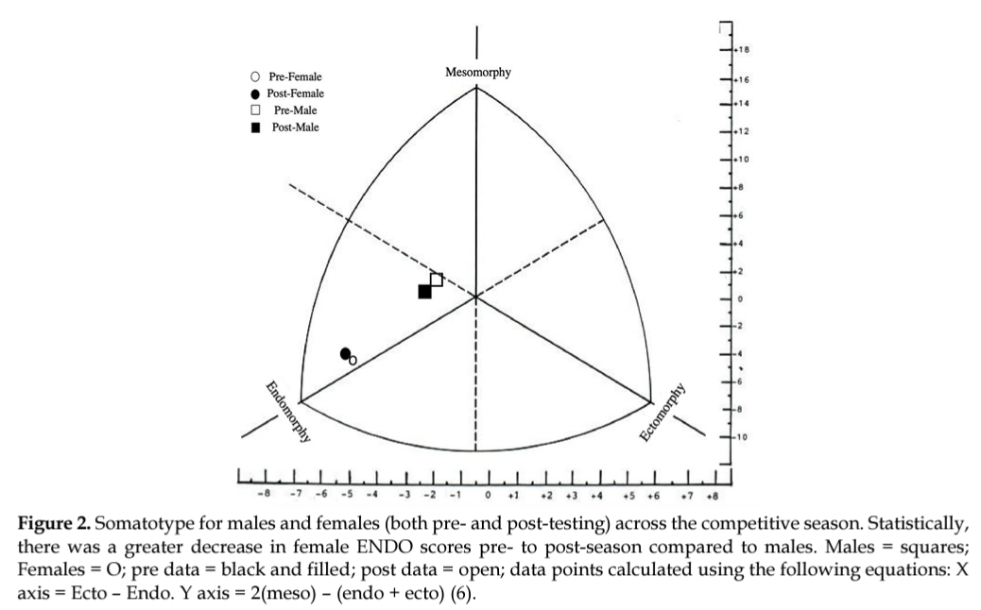

Results have multiple pieces of evidence for the findings (See [Johnson et  al., (2020](https://digitalcommons.wku.edu/ijes/vol13/iss1/1/)). In most cases, this will take the form of appropriate measures of effect accompanying all reported results (e.g., *p* values).

*Example*

The results of a two-way, repeated-measures ANOVA revealed that there was no interaction effect (Time x Treatment) [F(1,8) = 0.075, *p* = 0.79, ES = 0.27] nor main effect of treatment (CON vs PAPE)[F(1,8) = 0.084, *p* = 0.78, ES = 0.31]. However, there was a main effect of Time (Session 1 vs Session 2) [F(1,8) = 58.87, *p* < 0.001, *d* = 0.25].

# Discussion

The discussion section interprets the study's results, connecting them to the research question, previous literature, and broader implications. It explains the significance of the findings, highlights how they contribute to the field, and explores their practical or theoretical relevance. This section also acknowledges study limitations, providing a balanced perspective and suggesting ways to address them in future research. Additionally, the discussion outlines unanswered questions, proposes new hypotheses, and offers recommendations for further investigation, ensuring the findings are placed within the larger context of the discipline.

# References

Format references as noted under our style guide (AMA format). In general, please follow the following format for scientific articles:

AuthorLastname FirstInitialMiddleInitial. Title in sentence case. *Abbreviated Journal Title in Title Cas*e. Year;volume(Issue#):PP-PP. https:doi: ##

*Example:*

Reeves R, Hicks O, Navalta JW. The relationship between upper arm anthropometrical measures and vertical jump displacement. *Int J Exerc Sci*. 2008;1(1):22-29. <https://doi.org/10.70252/FJTF9033>

References should be numbered in the reference list, based on the order presented in the text. Citations in the text should be numbered according to their reference list location.

Check DOI by using this link: <https://apps.crossref.org/SimpleTextQuery>

Ensure it is a connected link

Original research manuscripts are limited to 40 references (the exception would be for systematic reviews with or without meta-analyses).

* **Type in the number of references included in your submission.  _____**

Add a 10 pt space between each reference.

# Acknowledgements

Consider providing a land acknowledgement as a way of showing respect for the Indigenous Communities with whom the work was performed, or whose historic land was taken, now being used by academic institutions and its employees. The National Environmental Education Foundation provides guidance on creating a land acknowledgement. The process involves first identifying the traditional inhabitants of the land at https://native-land.ca . Next, while there is no precise language recommendation, an articulation of acknowledgement is appropriate (see the example below). Finally, once the statement has been created, include the acknowledgement in the manuscript.

Example land acknowledgement: “We respectfully acknowledge that the International Journal of Exercise Science, and Western Kentucky University, are headquartered and located on the ancestral land of the ᏣᎳᎫᏪᏘᏱ Tsalaguwetiyi (Cherokee, East) people.”

Signature of corresponding author

___________________________________

**Add this checklist after your cover letter**

# Systematic Reviews and Meta-Analyses

## Preferred Reporting Items for Systematic Reviews and Meta-Analyses (PRISMA)

### In Text

To ensure transparency of methods and interpretation, authors submitting a systematic review with or without a meta-analysis need to complete and include the appropriate PRISMA checklist in the submission. These can be found at <https://www.prisma-statement.org/>, and include checklists for various types of reports such as:

* Systematic reviews and meta-analyses (PRISMA),
* Systematic reviews and meta-analyses of individual patient data (PRISMA-IPD),
* Network meta-analyses (PRISMA-NMA), and
* Scoping reviews (PRISMA-ScR).

### In Cover Letter

Authors submitting a systematic review with or without a meta-analysis must complete and include the following in their cover letter:

* The appropriate PRISMA checklist for the study design (duplicate from submission),
* The PRISMA for Searching (PRISMA-S), and
* The PRISMA checklist for abstracts.

Authors should indicate in each of these checklists the line number at which each item appears. Any items not included in the manuscript should be noted by “N/A” in the checklist. An additional page should be used to explain why items were excluded. All three documents should be appended to the end of the cover letter document.

☐ All three PRISMA checklists above are completed

☐ Line numbers for each item are included in the checklists

☐ An additional page is included to justify excluded items

☐ All three documents are appended to the end of the cover letter document

## Study Quality Assessment

For systematic reviews with or without meta-analyses, authors must include an assessment of methodological study quality, such as the PEDro or Jadad scales for randomized controlled trials. The selected assessment tool should be appropriate for the study design and its use justified in the methods section of the manuscript. See an incomplete list [here](https://asklib.hsl.unc.edu/faq/366855) (note: The Systematic Reviews and Meta Analyses options should not be used as these are meant to assess the quality of systematic reviews and meta-analyses). If a custom or novel study quality tool is used rather than a pre-existing one, it needs to be thoroughly explained and justified in the methods section. A summary of the quality assessment for each study should be presented in a table in the manuscript.

Examples

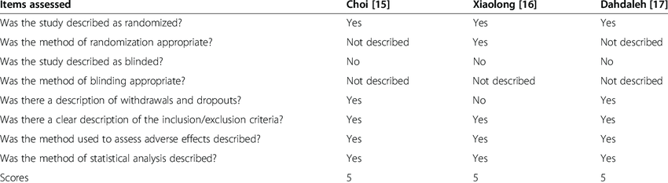

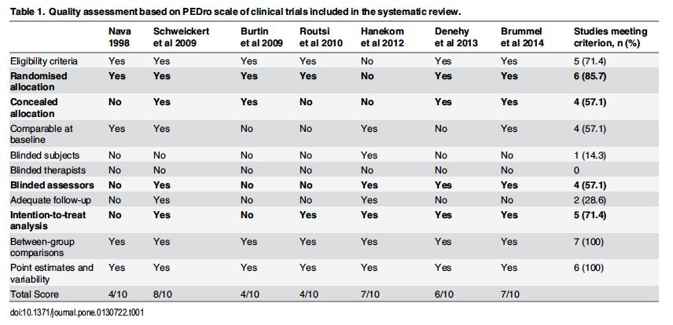

Checklist for authors (the Original Research and Qualitative Research checklists may be deleted):

☐ If using a pre-existing study quality assessment tool (preferred):

☐ A study quality scale was used to determine methodological quality of each study

☐ Use of assessment tool is justified in the methods (line number: _______________)

☐ Results of the study quality assessment are presented as a supplementary table

☐ If using a novel or custom study quality assessment tool:

☐ Tool is described and justified in the methods (line number: _______________)

☐ A copy of the assessment tool is appended to the end of the document

☐ Results of the study quality assessment are presented as a supplementary table

Please note that absence of any of these criteria will result in the submission being rejected. Due to the high volume of submissions to IJES, only transparent and thorough systematic reviews and meta-analyses will be passed along to the peer review process.

For Systematic Reviews with or without Meta-Analyses

Authors submitting a systematic review/meta-analysis must complete and include the following in their cover letter:

* The appropriate PRISMA checklist for the study design (duplicate from submission),
* The PRISMA for Searching (PRISMA-S),
* The PRISMA checklist for abstracts

Authors should indicate in each of these checklists the line number at which each item appears. Any items not included in the manuscript should be noted by “N/A” in the checklist. An additional page should be used to explain why items were excluded. All three documents should be appended to the end of the cover letter document.

☐ All three PRISMA checklists above are completed

☐ Line numbers for each item are included in the checklists

☐ An additional page is included to justify excluded items

☐ All three documents are appended to the end of the cover letter document

References must be formatted as described for Original Research submissions.

Consider acknowledgements as described for Original Research submissions.

Signature of corresponding author

___________________________________

**Add this checklist after your cover letter**

# Qualitative Research

For qualitative study designs, the editors will look for the following components (you may delete the other checklists).

If the research incorporated an interview guide, authors should explain how the guide was developed, including use of bracketing and pilot interviews.

* **Type the line number where this is found ______**

Description of the descriptive-interpretive framework used to interpret study findings (See [Timulak & Elliott, 2019](https://doi.org/10.1002/capr.12197) ). As a part of this summary, a description of theoretical underpinnings or philosophical assumptions may be provided to explain/rationalize the *a priori* approach to data collection, analysis, and interpretation of study results.

* **Type the line number where this is found ______**

Use of reflexivity in the study report (See [Rogers et al., 2021](https://doi.org/10.1016/j.psychsport.2020.101827)). Reflexivity is reflective writing by the study author/team that acknowledges factors (e.g., constraints/concerns/experiences or personal values/intentions) that motivated or affected their investigation, how those factors were navigated, and how those factors limited or supported the author/team’s ability to generate or interpret study findings (See [Ryan & Webster, 2019](https://link.springer.com/chapter/10.1007/978-981-32-9401-1_5)). At minimum, reflexive writing should appear within the Methods section. However, reflexive writing may also appear in other sections of the report, such as the Results and Discussion section.

* **Type the line number where this is found ______**

A summary of the process used to ensure a rigorous study design and trustworthy findings (e.g., results confirmation, critical friend methodology, member checking procedures).

* **Type the line number where this is found ______**

For mixed-methods study designs, the editors will look for the following components: a brief description of qualitative and quantitative methodologies used in the study, and a concise rationale for the mixed-methods study design.

Regardless of study design (i.e., qualitative, quantitative, mixed-methods), the editors will look for a concise description and rationale for the following components: sampling procedure, data collection, and data analysis.

If the submitted study involved human participants, authors must include an ethics statement as described for Original Research submissions.

Specific to the variable of sex or gender, consider reporting how this data was collected in a respectful and inclusive manner, ideally allowing participants to self-identify and ensure that specific questions about gender identity and sexual orientation are relevant to the study's objectives (see [Navalta et al. 2024](https://digitalcommons.wku.edu/ijes/vol17/iss8/1/)).

References must be formatted as described for Original Research submissions.

Consider acknowledgements as described for Original Research submissions.

Signature of corresponding author

___________________________________

**Add this checklist after your cover letter**